Comprehensive
- Set up/Import Data
  - Make this file path: “drive/My Drive/ECI Research/5. Datasets/2023 Fall - Data/2019-2022 cleaned"
  - Make a copy of GDP_2022.csv found in Data and move to Drive
  - Make a copy of 2019clean.csv, 2020clean.csv, 2021clean.csv, 2022clean.csv; move to your Drive
  - Change main_country and comparable_countries and sdv_comparable_countries
    - If updating country report for 2021/2022, make sure comparable countries are same as previous version
  - Double-check years are correct (2019, 2022)
  - Import data: double-check formatting of country name and ECI/GDP dictionaries match
- ECI & PCI
  - Run cells as is
  - Save the following:
    - 2019-2022 ECI of main country and comparable countries
    - GDP comparison graph
    - Aagrate of GDP for main country and comparable countries
    - ECI comparison graph
    - ECI change of 4 countries
    - GDP and ECI trend for main country
- Proximity, Distance, and RID
  - Run cells as is
- Sequential Strategy
  - Run cells as is
- SDV & SIDS
  - Run cells as is
  - After running the cell that starts with “# UPDATED - SDV for multiple countries with main_country”
    - Navigate to the folder icon on the left banner; download the sequential vector xls file of your 4 countries. Combine the columns into a single dataframe in excel
      - Add ECI for each country to bottom row
      - Formatting (follow image or template)
        - Copy your assigned country to the leftmost column
        - Add the 3 chosen countries to the right
        - Label the columns with the corresponding country name
        - Center the text in the first column, first row, and last row
        - Expand the columns so that the text does not overlap
        - Remove gridlines
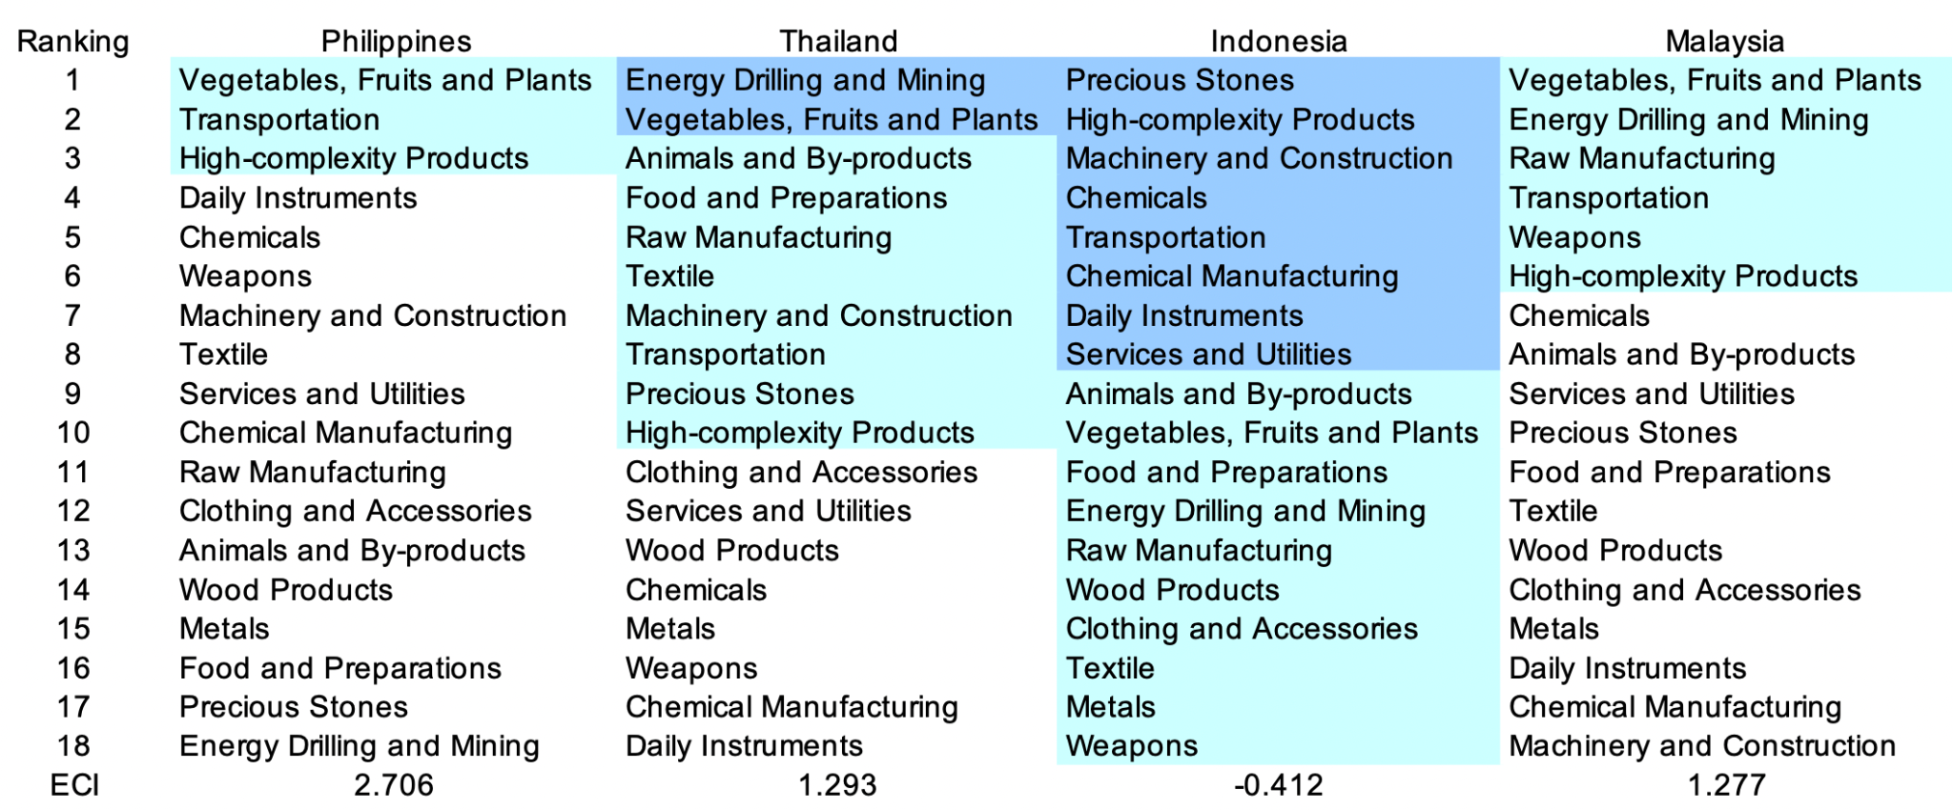
- SOI
  - Run as is
  - SOI w/ ADI
    - Run as is
    - Make sure country_list in compute_soi_adi function is updated with main country and comparable countries
    - Save SOI plot
    - Record R^2 value directly above SOI plot
- Greedy Algorithm
  - Prep: add a folder in 5. Datasets in My Drive named New_result_update
  - Make sure file path is correct
  - Run metrics calculations as is
  - Run Greedy and Plot cells as is
  - Running greedy
    - Check country, end year (2022) is correct
    - Run 5% and dump into pickle file; check that pickle file has saved in New_result_update
    - Run 10% and dump into pickle file
    - Run 15% and dump into pickle file
    - Run 20% and dump into pickle file
  - Plot budget allocation
    - Check country and file paths are correct
    - Run cells as is
    - Download 2 figures
      - ECI growth optimization result
      - ECI increment
    - Run tableau cells as is
    - Download tableau [main country] 2022.xls from left hand side folder icon
        - Format the Excel like this and export as pdf/screenshot
        - Add in a line in the second row of the original ECI form Step 3a of this doc
        - Format the values in scientific notations and merge/center
        - Color the border cells dark blue and body light blue
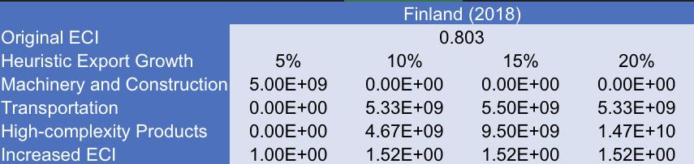
- Sensitivity
  - Run import packages, read data, and metrics calculations as is
  - Check for print statement “Sensitivity defined”
  - Make sure raw_matrix is defined with 2022 data
    - raw_matrix=read_country(root_path + '2022clean.csv')
  - Download positive and negative shocking plots
- SDV sensitivity and contingency strategy
  - Add or find the cells that say sensitivity_new(raw_matrix, main_country, “High-complexity Products, root_path) and sensitivity_new(raw_matrix, main_country, "Clothing and Accessories", root_path)
  - Find the two .xlsx files main_countryHigh-complexity Products.xlsx and main_countryClothing and Accessories.xlsx in drive/My Drive/ECI Research/5. Datasets/2023 Fall - Data/2019-2022 cleaned
  - Format like below: In the first sheet, there are columns with percentages and numbers to the right. The numbers directly to the right indicate if color of the percentage column (shown below). Dark blue is positive, white is 0, and light blue is negative
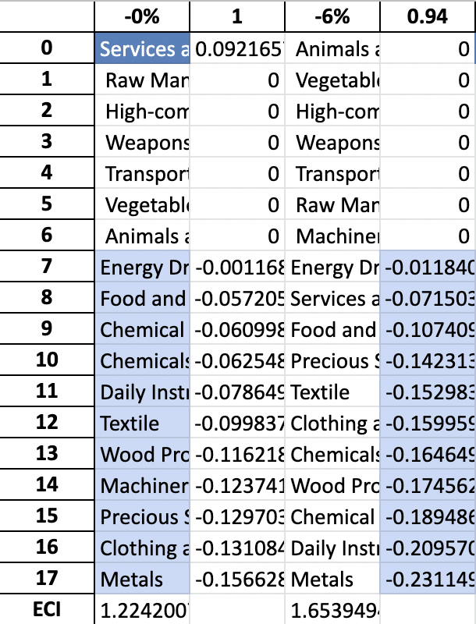
  - Contingency
    - Add cell or find cont(main_country,raw_matrix, root_path)
    - Go to drive/My Drive/ECI Research/5. Datasets/2023 Fall - Data/2019-2022 cleaned and download main_country_contingency.xlsx
    - Center and bold cells like below
